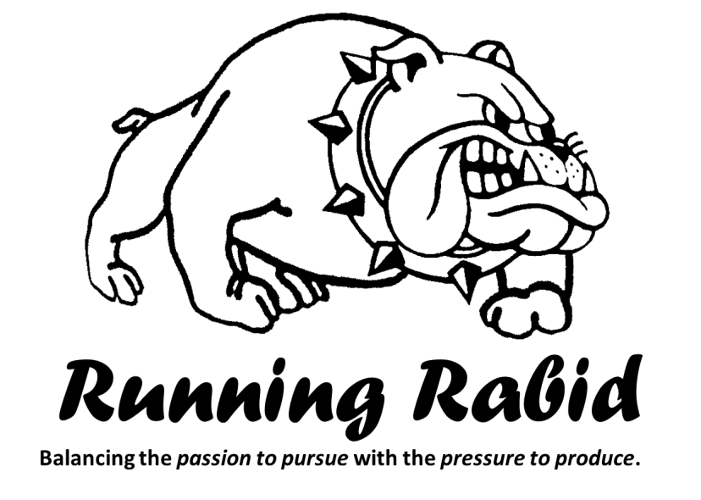
Running Rabid – MBC Men’s Fall 2015 12-week Series

- The pressure of expectations: Little boys dreams: pilots, soldiers, and kings – 9.17.15
- The pressure from society to conform (metrics) – 9.24.15
- The pressure from work to produce – 10.1.15
- The pressure from family to provide – 10.8.15 (Law enforcement appreciation night: 10.15.15)
- The pressure from ourselves to be worthy – 10.22.15

- Truth from Scripture - learning to trust in God and His plans for our lives – 10.29.15
- The power of me: When I am weak then He is strong; self-reliance versus self-sacrifice – 11.05.15
- The power of rest – 11.12.15
- The power of prayer – 11.19.15
- The power of accountability and the need for discipline and self-restraint – 12.03.15

- Re-prioritizing our priorities: major in the majors and minor in the minors – 12.10.15
- Mirror time: making the main thing the main thing: Bema prep – 12.17.15

